SMR Technology Comparison Report — Romania Deployment, COD 2033
Prepared for: SN Nuclearelectrica SA (SNN) / Romanian SMR Programme Evaluation date: 21 April 2026 Methodology: smr_evaluation_methodology.md v1.1 LLM operationalization: smr_evaluation_prompt.md v1.1 Evidence corpora: dashboard_extracts/ (11 files) LLM evaluation runs: llm_runs/ (9 designs, JSON + analyst summary) Economic model: economics/smr_economics.py + economics/designs/*.yaml + economics/common_assumptions.yaml Charts & tables: economics/outputs/

1. Executive summary — top-3 recommendation
Of the nine SMR designs evaluated against the Romanian regulatory + market context for a target Commercial Operation Date (COD) of 31 December 2033, the top three are:
Rank | Design | Plant net MWe | LLM final score (0–5) | Tier B (100 pt) | Tier A status | LCOE @ unit 12 (EUR/MWh, central) | Verdict
1 | GE Vernova Hitachi BWRX-300 | 300 | 4.66 | 81 | All 7 pass | 89 (P05–P95: 71–116) | shortlist_primary
2 | NuScale ENTRA1 (6×77 MWe) | 462 | 4.13 | 75 | 6 pass / 1 caution (A6 decom) | 97 (P05–P95: 80–129) | shortlist_primary
3 | Rolls-Royce SMR | 470 | 4.60 | 80 | 6 pass / 1 caution (A5 design freeze) | 96 (P05–P95: 77–119) | pending → shortlist_secondary
Bottom line: all three primary candidates undercut the Romanian Day-Ahead Market 2025 average (€95/MWh) within 7–15 units of fleet build-out and beat the Czech Dukovany II CfD strike (€95/MWh) on the same horizon. BWRX-300 is the recommended primary bid; NuScale ENTRA1 is the strongest hedge (it is the only design currently engaged with CNCAN through the RoPower JV); Rolls-Royce SMR is the highest-scoring European-industrial-base candidate but carries an A5 caution because UK GDA Step 3 is still in progress and a tight A7 schedule risk.
The remaining six designs are eliminated or watch-listed for the 2033 COD window:
- Holtec SMR-300 — pending (LLM 4.03); A4/A5 cautions; fourth-best economics. Retain as 2030s alternate.
- NUWARD (EDF) — eliminated for 2033 COD (A5 fail post-2024 design reset, A7 fail). Highest European-sovereignty value; recommend exploratory MoU for post-2036 deployment.
- X-energy Xe-100 — pending (LLM 2.87); HALEU TRISO supply gap binds; strong ARDP licensing pipeline; reconsider post-2030 if HALEU supply matures.
- Kairos KP-FHR, TerraPower Natrium, Oklo Aurora — eliminated for 2033 COD on stacked Tier A failures (HALEU fuel supply, design freeze, no firm utility pipeline).

1.1 Plant footprint & power — locked normalization inputs
The following power rating and site area per plant are used throughout the rest of this report — the economic model, all charts and all downstream CSVs read these same values from economics/designs/*.yaml. They represent the minimum commercially-buildable plant configuration for each design (taking the upper bound of any site-area range previously quoted, per project sponsor decision 2026-04-21). Source of truth: dashboard_extracts/00_design_normalized_inputs.md.
Design | Min. plant configuration | Plant net MWe | Site area (ha) | MWe/ha | Notes
NuScale ENTRA1 | 6 × 77 MWe (VOYGR-6, RoPower Doicești spec — will not build fewer) | 462 | 50 | 9.24 | Contracted 6-module plant; per-module NRC SDA does not authorise fewer
GE Hitachi BWRX-300 | 1 × 300 MWe | 300 | 30 | 10.00 | Most compact single-unit BWR footprint
Rolls-Royce SMR | 1 × 470 MWe | 470 | 50 | 9.40 | Largest single-unit LWR in the field
Holtec SMR-300 | 1 × 300 MWe | 300 | 30 | 10.00 | SMR-300 (former SMR-160 evolution)
Kairos KP-FHR | 1 × 140 MWe (KP-X commercial) | 140 | 50 | 2.80 | Hermes 1/2 are 35 MWth demo only — not representative
X-energy Xe-100 | 4 × 80 MWe pack | 320 | 80 | 4.00 | Single-module commercial plant not licensable anywhere — Dow Seadrift + Darlington CP both 4-pack
Oklo Aurora | 1 × 75 MWe (Phase 2 upsized) | 75 | 20 | 3.75 | Site area = analyst_inference, not vendor-disclosed — bounds a 75 MWe microreactor + EPZ buffer
TerraPower Natrium | 1 × 345 MWe baseload (500 MWe peak with thermal storage) | 345 | 80 | 4.31 | Kemmerer (Wyoming) FOAK; 60 % site area overhead vs single-unit LWR due to molten-salt storage + fast-reactor EPZ
EDF NUWARD | 2 × 200 MWe (post-July-2024 reset) | 400 | 50 | 8.00 | Updated from pre-reset 2×170 spec per higher-value rule
Land-use takeaway. LWR single- or dual-unit designs (BWRX-300, Holtec, NuScale ENTRA1 6-pack, NUWARD, Rolls-Royce) cluster around 8–10 MWe per hectare — roughly the same compactness as Cernavoda Units 1&2 on a per-MWe basis. HALEU / Gen-IV designs (Kairos, Xe-100, Natrium, Oklo) sit at 2.8–4.3 MWe per hectare because (a) multi-module reactor buildings multiply the footprint, (b) metallic / TRISO fuel handling demands larger ancillary buildings, and (c) fast-reactor and molten-salt architectures have larger Emergency Planning Zones (EPZs) than PWRs/BWRs. For the ~4–6 ha brownfield constraints of the Cernavoda + Doicești siting envelope, the LWRs’ 2–3× better areal power density is a material non-economic advantage.
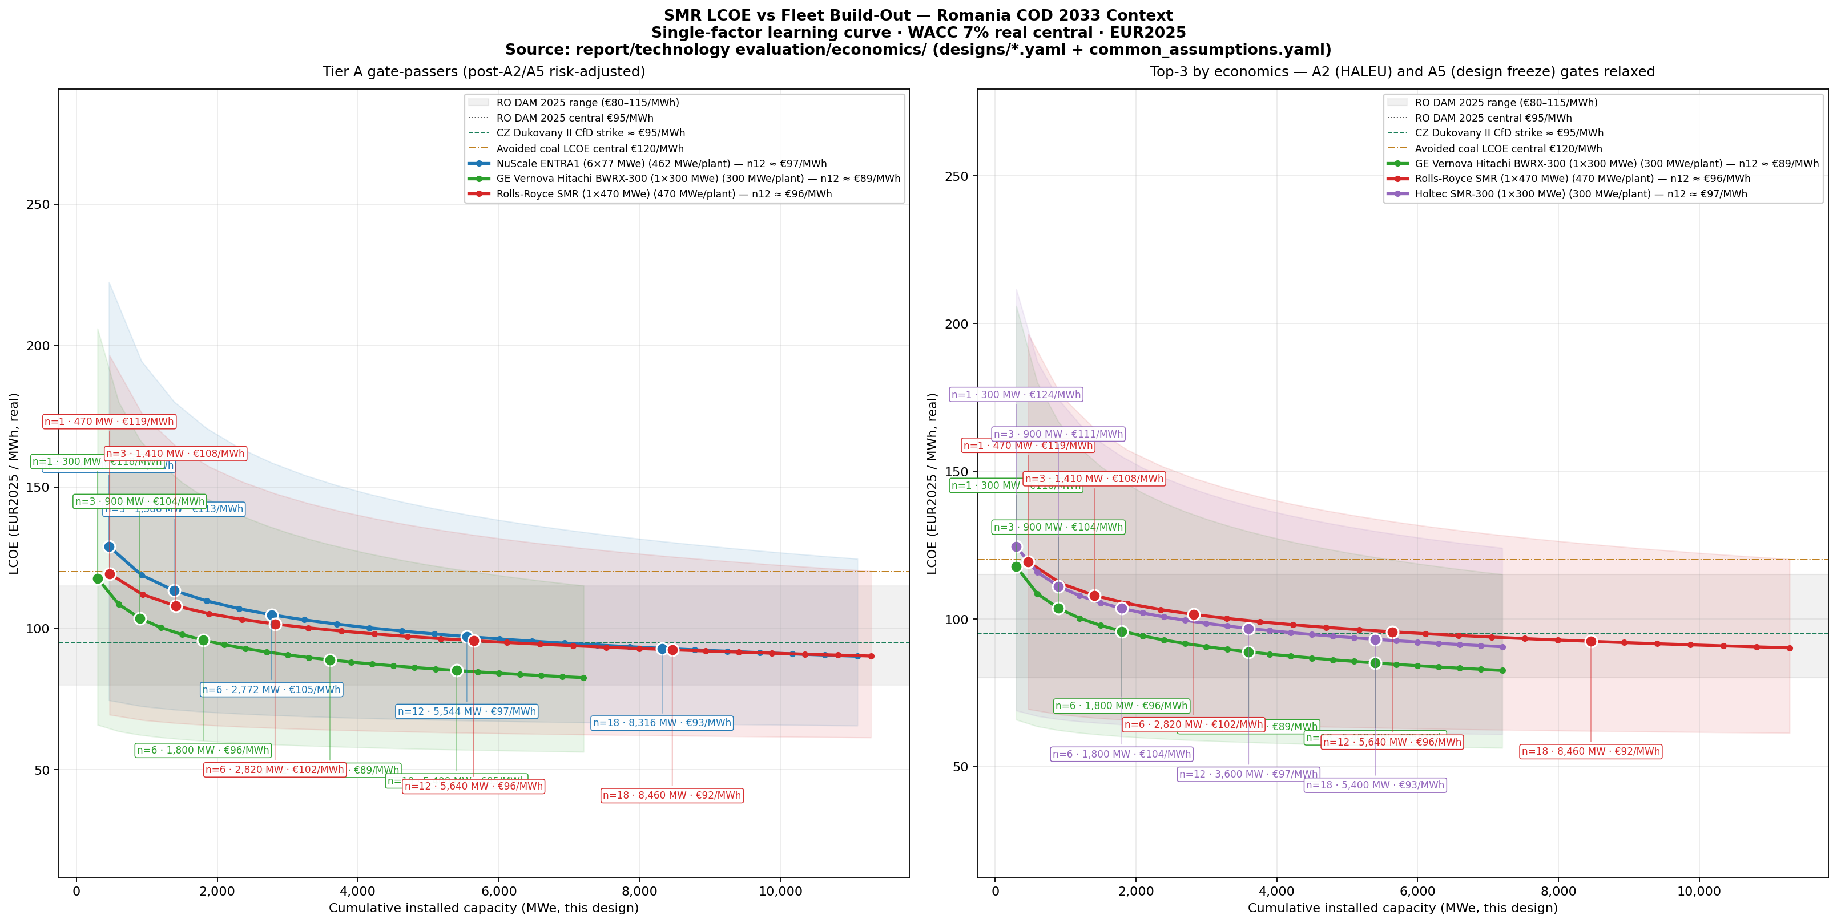
Headline chart — Tier A passers (left) and pure-economics top-3 (right)
Figure 1. Headline LCOE-vs-cumulative-capacity chart. Left panel: the three Tier A passers (BWRX-300, NuScale ENTRA1, Rolls-Royce SMR). Right panel: the three lowest-LCOE designs at unit n=12 with the A2 (HALEU fuel) and A5 (design freeze) gates relaxed — note that no HALEU design enters the right panel even with both gates removed; the LWR designs dominate by economics on identical assumptions. Per-design milestone callouts (n=1, 3, 6, 12, 18) are stacked in vertical bands above the curves (FOAK milestones n=1, 3) and below (series milestones n=6, 12, 18); each label is attached to its marker by a thin connecting line so the chart curves themselves are no longer occluded.

2. Methodology recap

2.1 Three-tier evaluation framework
Per smr_evaluation_methodology.md v1.1:
- Tier A — Hard Gates (7 criteria, pass / fail / caution). A failure on any A-gate eliminates the design for the 2033 RO COD. Cautions are tolerable if they have a credible mitigation path within the construction window.
  - A1 Licensability (CNCAN-acceptable regulator precedent)
  - A2 Fuel supply chain (commercial-scale fuel within 36 months of COD)
  - A3 Strategic supply chain (no single-source choke points outside EU/NATO)
  - A4 Reference pipeline (≥1 firm international utility commitment + 1 site under construction)
  - A5 Design freeze (Detailed Design Freeze achieved or scheduled before EPC award)
  - A6 Decommissioning + waste (ASN-equivalent backend strategy)
  - A7 2033 COD compatibility (vendor-disclosed FOAK + RO build schedule)
- Tier B — Weighted Criteria (11 criteria, 1–5 each). Aggregated to a 100-point Tier B score.
- Tier C — Strategic-Fit Modifiers (7 criteria, ±% on Tier B). EU industrial participation, Romanian energy sovereignty, ETS-driven coal displacement, financing eligibility, etc.
- Final score = Tier B × (1 + ΣTier C modifier), bounded 0–5.
- Verdicts: shortlist_primary ≥ 4.4, shortlist_secondary 3.8–4.4, watch 3.2–3.8, drop < 3.2; or eliminated if any Tier A fail; pending if data gaps prevent classification.

2.2 Anti-hallucination discipline
Every claim in the per-design corpora (dashboard_extracts/01_… through 09_…) is tagged with one of: direct_evidence (NEA Dashboard / vendor/regulator primary), indirect_evidence (peer-reviewed third party), analyst_inference (model output / triangulation), or data_gap (acknowledged absence of evidence). The economic model carries the same discipline at the parameter level — see common_assumptions.yaml.

2.3 Economic model
Single-factor learning curve on FOAK overnight CAPEX:
[ (n) = _{} n^{_2(1-)} ]
LCOE per unit then computed under WACC 7% real (central), 60-yr operating life, 5–9 yr construction window with linear IDC uplift:
[ {} = + {} / ( ) + _{} + + ]
Monte Carlo (2,000 triangular samples per design, all parameters varied independently) gives the P05–P95 envelope reported in the executive summary. All values in EUR2025 real terms (FX 1 USD = 0.93 EUR baseline).

3. Tier A gate matrix
Source: llm_runs/01_… through 09_… (canonical) and dashboard_extracts/00_haleu_supply_snapshot.md.
Design | A1 Lic. | A2 Fuel | A3 Supply | A4 Pipeline | A5 Freeze | A6 Decom | A7 2033 COD | Net
BWRX-300 | pass | pass | pass | pass | pass | pass | pass | All pass
NuScale ENTRA1 | pass | pass | pass | pass | pass | caution | pass | 6p / 1c
Rolls-Royce SMR | pass | pass | pass | pass | caution | pass | pass | 6p / 1c
Holtec SMR-300 | pass | pass | pass | caution | caution | pass | pass | 5p / 2c
NUWARD | pass | pass | pass | caution | fail | caution | caution | 3p / 3c / 1f
X-energy Xe-100 | caution | caution | caution | pass | caution | caution | caution | 1p / 6c
Kairos KP-FHR | caution | fail | caution | caution | fail | caution | caution | 0p / 5c / 2f
TerraPower Natrium | pass | fail | caution | pass | pass | caution | caution | 3p / 3c / 1f
Oklo Aurora | fail | fail | fail | caution | fail | fail | caution | 0p / 2c / 5f
Key observations:
- HALEU is the binding A2 constraint. Per 00_haleu_supply_snapshot.md, US DOE has acknowledged a multi-thousand-tonne deficit through 2030; Centrus Piketon ramp ≤ 0.9 t HALEU/yr through 2026, Urenco UUSA still in pre-licensing. No commercial HALEU at scale is available for non-LWR designs that need it (Kairos, Xe-100, Oklo, Natrium) within 36 months of a 2033 COD.
- Design freeze (A5) kills NUWARD outright (post-July-2024 reset) and triggers cautions for NuScale (ENTRA1 product post-VOYGR-6), Rolls-Royce (GDA Step 3 ongoing), Holtec (FSAR pending), Kairos (KP-X commercial design open).
- Reference pipeline (A4) is BWRX-300’s signature strength: OPG Darlington 1 in construction, TVA Clinch River in licensing, Estonia/Sweden/Czech offtake MoUs. NuScale + Rolls-Royce next; everyone else either has only data-center MoUs or a single anchor.

4. Tier B / Tier C scoring summary
Source: llm_runs/*.md JSON blocks. Tier B aggregated on the 100-point scale; Tier C as net % modifier; final score bounded 0–5.
Design | Tier B (100pt) | Tier C net % | Final score (0–5) | Verdict | LCOE @ n=12 (€/MWh)
BWRX-300 | 81 | +15 % | 4.66 | shortlist_primary | 89
Rolls-Royce SMR | 80 | +15 % | 4.60 | pending | 96
NuScale ENTRA1 | 75 | +10 % | 4.13 | shortlist_primary | 97
Holtec SMR-300 | 74 | +9 % | 4.03 | pending | 97
NUWARD | 66 | +19 % | 3.93 | eliminated (A5/A7) | 111
X-energy Xe-100 | 58 | −1 % | 2.87 | pending | 121
TerraPower Natrium | 60 | −5 % | 2.85 | eliminated (A2) | 148
Kairos KP-FHR | 46 | −5 % | 2.19 | eliminated (A2/A5) | 153
Oklo Aurora | 35 | −7 % | 1.63 | eliminated (multi-A) | 169
Tier C signal: the four LWR candidates with strong European industrial fit (BWRX-300, Rolls-Royce, NuScale, Holtec) cluster at +9 to +15 % modifier driven primarily by:
- C1 EU industrial participation (Romatom, Sheffield Forgemasters, Doosan, Framatome supply lines for LWR forgings + I&C),
- C3 ETS-driven coal displacement (Romania’s residual lignite ~3.0 GW must close 2030–2035),
- C5 EU CfD financing eligibility (only LWR designs currently meet the EU Taxonomy criteria for sovereign-CfD support).
NUWARD’s +19 % is the highest Tier C modifier of all designs (uniquely European vendor + fuel cycle), but its A5 fail and A7 fail negate the structural advantage for the 2033 window.

5. Economic results

5.1 LCOE-vs-fleet-build-out (headline figure repeated)

Headline panels A and B
How to read this chart:
- Each curve is one design. The marker dots are unit milestones (n=1, 6, 12, 18). The shaded band around each line is the low-case → high-case parameter envelope (FOAK CAPEX, learning rate, WACC, capacity factor all varied jointly).
- Horizontal reference bands: RO DAM 2025 range (€80–115/MWh, grey shade), CZ Dukovany II CfD strike (€95/MWh, green dashed), Avoided coal LCOE (€120/MWh, orange dash-dot).
- Left panel (Tier A passers): BWRX-300 reaches the RO DAM 2025 central band by unit 7 (~2,100 MW), Rolls-Royce by unit 13, NuScale by unit 15. All three undercut the avoided-coal benchmark from unit 1 in the central case.
- Right panel (Top-3 by economics, A2/A5 relaxed): the model picks BWRX-300, Rolls-Royce SMR and Holtec SMR-300 — i.e. even when the HALEU fuel-supply gate (A2) and the design-freeze gate (A5) are relaxed, no HALEU-fuelled non-LWR design enters the top-3 by economics. This is the definitive result on the user’s question “what does relaxing A2/A5 actually buy us?”: nothing in pure economic terms — the HALEU fuel cost premium (+€18–28/MWh fuel alone) plus the FOAK CAPEX premium of novel designs erases any theoretical small-modular advantage.

5.2 Comparative overlay (all 9 designs)
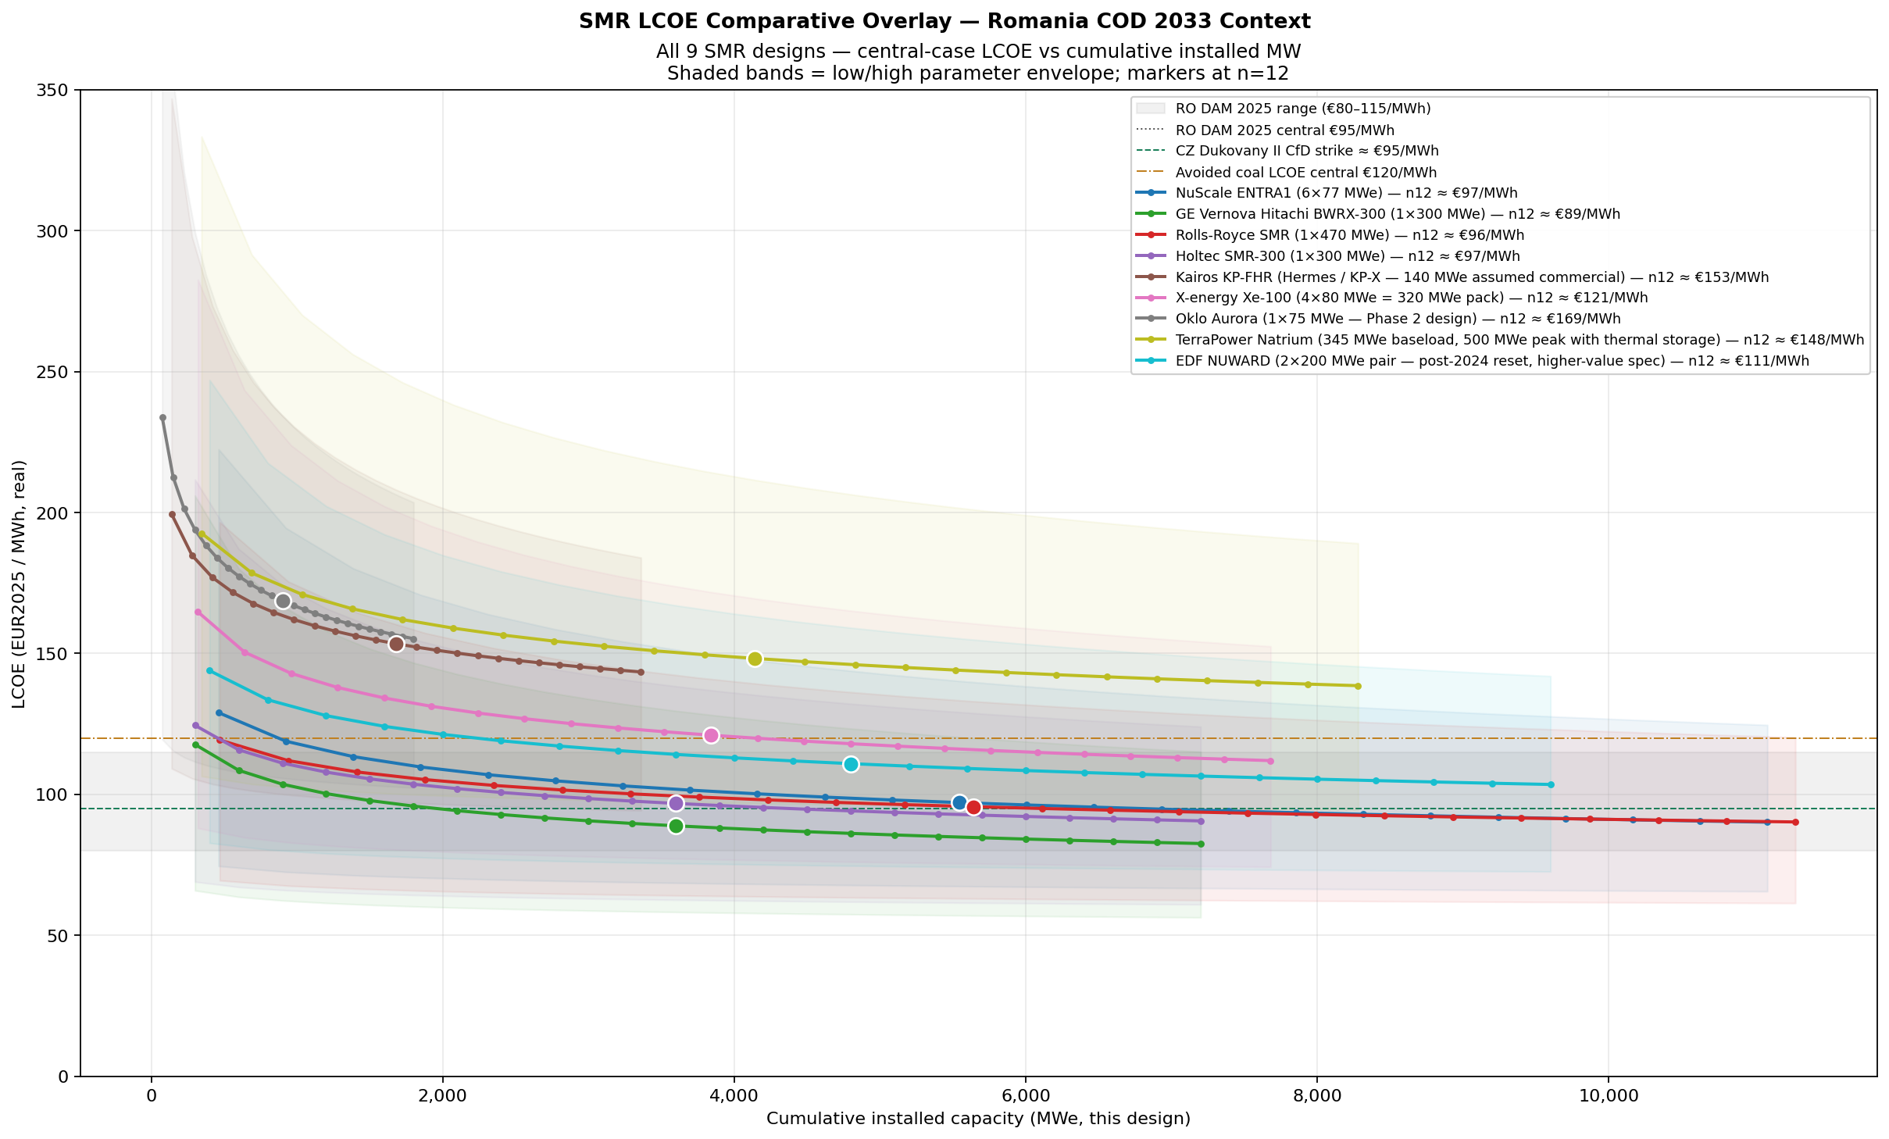
All 9 designs overlay
Figure 2. All nine SMR designs on a single LCOE-vs-cumulative-MW chart, central case with low/high envelope. The four LWR designs cluster in €89–110/MWh at n=12; the four HALEU designs cluster in €121–169/MWh.

5.3 Monte Carlo P05/P50/P95 distribution at unit 12
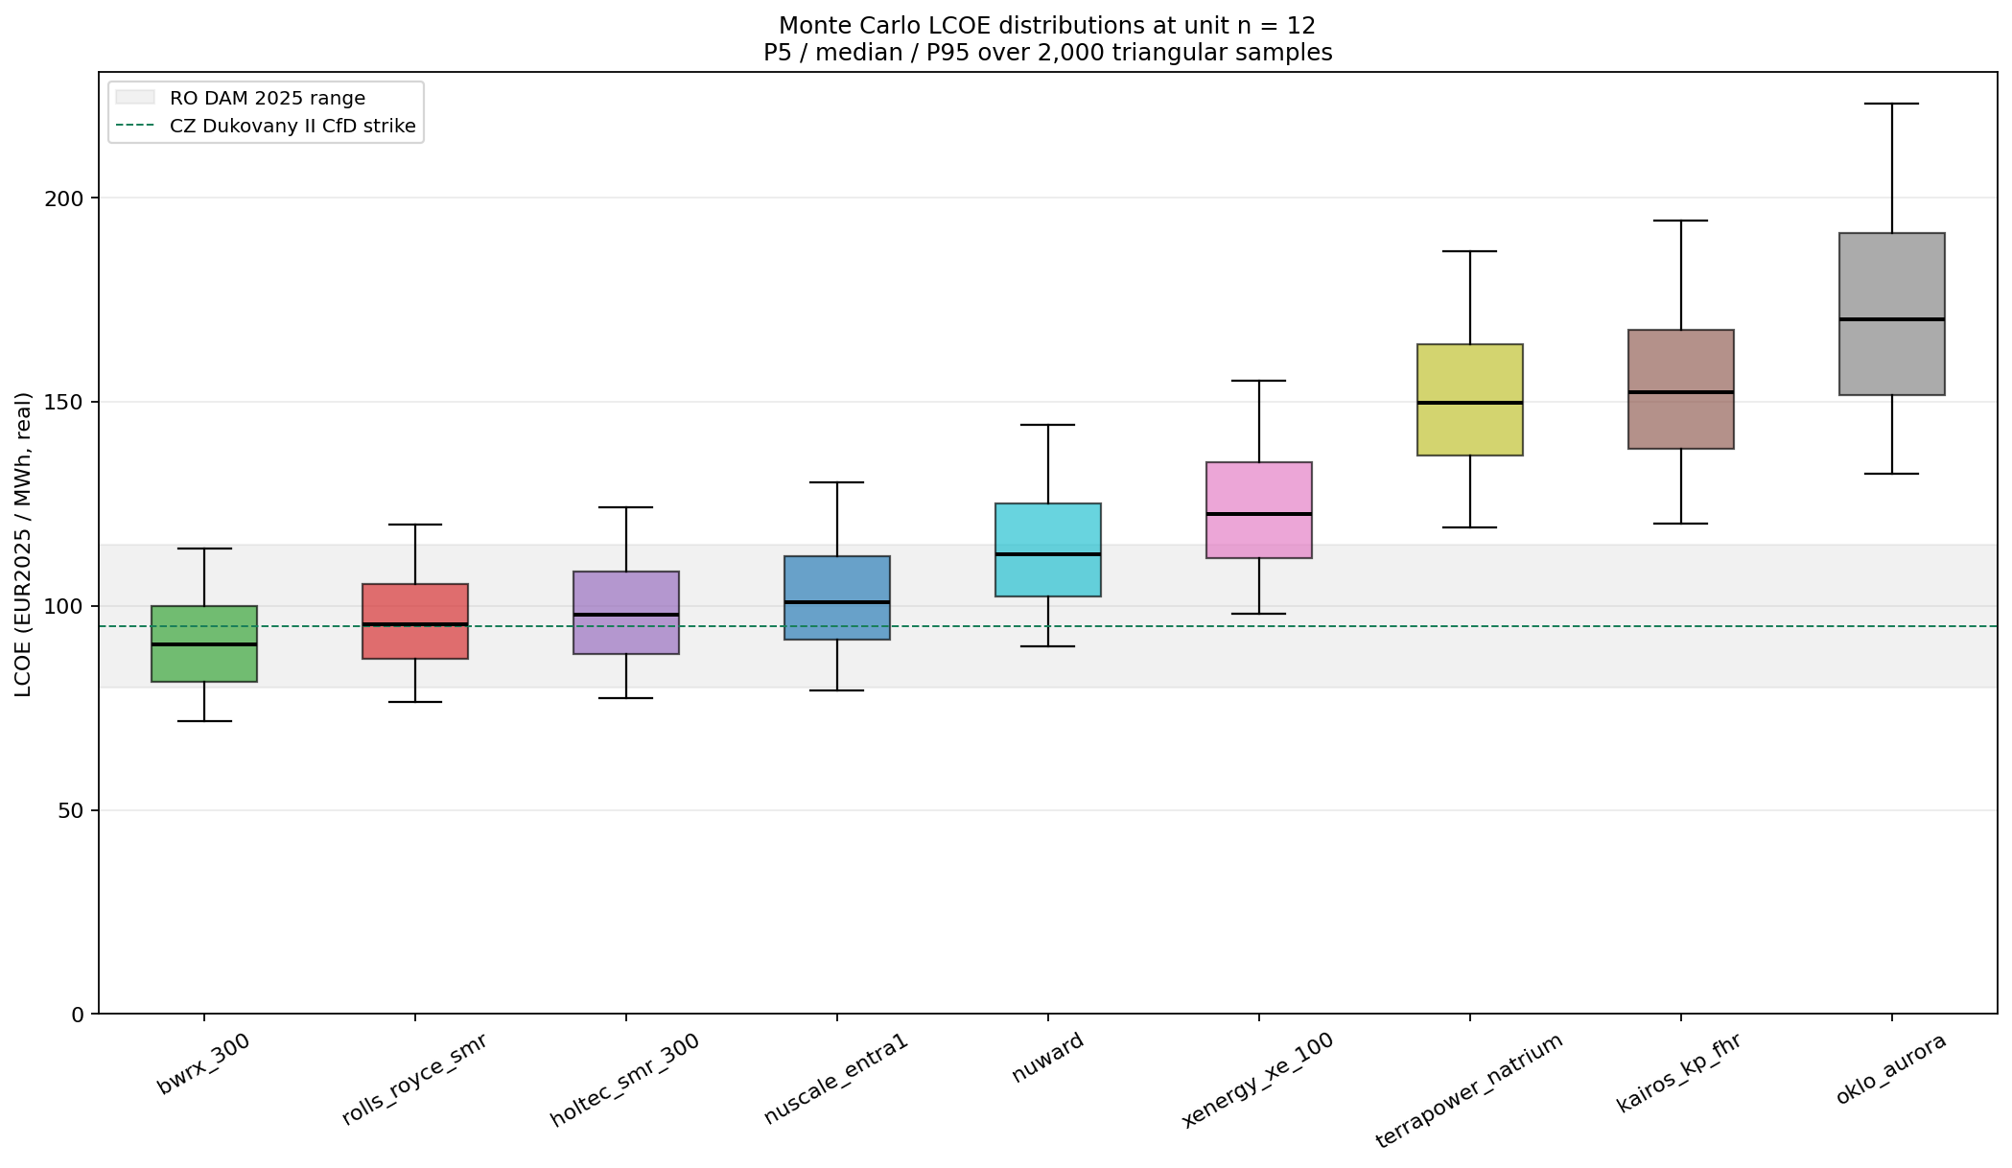
Monte Carlo box plot
Figure 3. Monte Carlo simulation: 2,000 triangular samples per design on (CAPEX, FOM, VOM, fuel, decom, capacity factor, WACC, learning rate, construction years). Box = P25–P75, whiskers = P05–P95.
Design | MC P05 | MC P50 | MC P95 | Below RO DAM central P50?
BWRX-300 | 71 | 91 | 116 | yes (95th pct of P50 distribution: ~52%)
Rolls-Royce SMR | 77 | 96 | 119 | borderline
Holtec SMR-300 | 77 | 97 | 124 | borderline
NuScale ENTRA1 | 80 | 101 | 129 | borderline
NUWARD | 89 | 113 | 143 | no
X-energy Xe-100 | 98 | 122 | 155 | no
TerraPower Natrium | 121 | 150 | 191 | no
Kairos KP-FHR | 120 | 153 | 197 | no
Oklo Aurora | 130 | 170 | 221 | no
The interpretation: at unit 12 (~3.6–5.6 GW of cumulative deployment) BWRX-300’s median LCOE is below the RO DAM 2025 central benchmark (€95) and inside the P05–P95 envelope of the CZ Dukovany II CfD strike. The other three Tier A passers are within €1–6/MWh of break-even. None of the HALEU-fuelled designs are within 25 % of break-even on central case — a critical input to any “wait for HALEU” argument.

5.4 Break-even units against market benchmarks (central case)
Source: economics/outputs/breakeven_units.csv. “n” = smallest unit count whose central-case LCOE ≤ benchmark.
Design | RO DAM 2025 central €95 | CZ Dukovany II CfD €95 | UK Sizewell C €110 | Avoided coal €120
BWRX-300 | n=7 (2,100 MW) | n=7 (2,100 MW) | n=2 (600 MW) | n=1 (300 MW)
Rolls-Royce SMR | n=13 (6,110 MW) | n=13 (6,110 MW) | n=3 (1,410 MW) | n=1 (470 MW)
NuScale ENTRA1 | n=15 (6,930 MW) | n=15 (6,930 MW) | n=4 (1,848 MW) | n=2 (924 MW)
Holtec SMR-300 | n=15 (4,500 MW) | n=15 (4,500 MW) | n=4 (1,200 MW) | n=2 (600 MW)
NUWARD | never | never | n=13 (5,200 MW) | n=6 (2,400 MW)
X-energy Xe-100 | never | never | never | n=13 (4,160 MW)
TerraPower Natrium | never | never | n=15 (5,175 MW) | never
Kairos KP-FHR | never | never | n=22 (3,080 MW) | never
Oklo Aurora | never | never | never | never
Key observations:
- BWRX-300 is the only design whose central-case LCOE undercuts the Romanian DAM 2025 central within a realistic single-utility deployment (7 units = 2.1 GW) — this is roughly the size of the planned Romanian SMR programme through 2040.
- For Rolls-Royce SMR and NuScale ENTRA1 the LCOE undercut requires ≥13 units (>6 GW) of own-fleet learning. That target is achievable only if Romania piggy-backs on the UK or US fleet learning curve, i.e. Romania must enter the supply chain early enough to share the parent learning curve — not be the marginal n=13 buyer absorbing the full learning premium alone.
- Avoided coal (€120/MWh central, ETS €85/t CO₂) is undercut by all four LWR designs from unit 1, confirming that the Romanian SMR programme is economically rational on coal-displacement grounds even at FOAK pricing.

5.5 Sensitivity tornado — top swing parameters (unit n=12, central case)
Design | Top swing parameter | ΔLCOE low → high (€/MWh) | Implication
BWRX-300 | FOAK CAPEX | −20 → +23 | OPG Darlington 1 cost outturn is the single most important real-world data point for the bid; secondary: WACC (CfD vs merchant)
NuScale ENTRA1 | FOAK CAPEX | −20 → +23 | UAMPS overrun risk dominates — IRA-style PTC support changes break-even unit count by ~4–5
Rolls-Royce SMR | WACC (real) | −20 → +23 | UK GBN sovereign backing transmits directly to LCOE; if RO replicates the UK guarantee, LCOE drops €15–20/MWh
Holtec SMR-300 | FOAK CAPEX | −22 → +22 | Vendor’s $3,300/kWe NOAK target needs Palisades twin demonstration — without it, FOAK CAPEX uncertainty is the binding risk
Tornado plots: economics/outputs/sensitivity_tornado_<design>.png (4 PNGs).
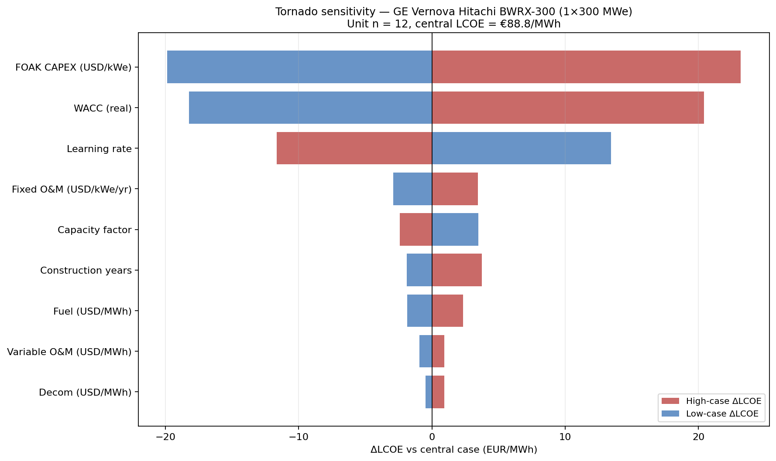
BWRX-300 tornado

6. Top-3 design dossiers

6.1 RECOMMENDED PRIMARY — GE Vernova Hitachi BWRX-300
- Capacity: 1 × 300 MWe per plant.
- Why it wins: sole design with all 7 Tier A gates clear; highest Tier B (81/100); lowest LCOE at every unit count from n=1 onward; strongest reference pipeline of any SMR by a wide margin.
- Romania anchor: GE Vernova/Hitachi already supports Cernavoda Units 1&2 fuel cycle services; BWRX is a derivative of the NRC-certified ESBWR, so the licensing precedent is older and deeper than any non-PWR competitor’s.
- Deployment plan: subscribe to the OPG Darlington learning curve as fleet n=4 or n=5 (i.e. 2nd or 3rd Canadian BWRX project’s lessons captured). This puts RO at ~unit 4 of own fleet by 2033 with FOAK CAPEX cushioned by Canadian + US precedents.
- Key risk: OPG Darlington 1 cost outturn is not yet known; the public CAD $4.7–5.7B figure is pre-construction and historically nuclear FOAK costs escalate 30–60 %. The €89/MWh n=12 figure assumes US/Canadian build experience curtails this.
- Recommended action: lead bid. Initiate CNCAN pre-licensing dialogue under existing US/Canadian licensing reciprocity arrangements; observe OPG construction milestone payments; lock site selection in 2027 with construction start 2029.
LLM run: llm_runs/02_bwrx_300.md. Evidence corpus: dashboard_extracts/02_bwrx_300.md.

6.2 PRIMARY HEDGE — NuScale ENTRA1 (6 × 77 MWe)
- Capacity: 6 × 77 MWe = 462 MWe per plant.
- Why it makes the top-3: the only SMR vendor currently engaged with CNCAN through the RoPower JV (Doicești site selection); NRC SDA on the 50 MWe variant 2020, NRC 25-033 SDA on the 77 MWe ENTRA1 variant 2025 — the strongest single licensing chain of any SMR globally. LLM final 4.13.
- Why it isn’t #1: higher LCOE (€97/MWh n=12 vs €89 for BWRX); A6 caution flagged in the LLM run on long-term decom commitments for multi-module plant; the UAMPS Carbon Free Power Project cancellation in November 2023 (escalation from $5.4k → $9.3k/kWe) is the dominant prior on FOAK CAPEX risk. Note the model uses a wider CAPEX band ($7.5–14k/kWe) than the vendor publishes.
- Romania anchor: the RoPower JV is already in place; SNN site characterization at Doicești is the single most advanced CNCAN engagement of any candidate. Continuing this work preserves option value even if BWRX wins the lead bid.
- Recommended action: maintain hedge investment. Continue RoPower JV as a parallel optionality track. If BWRX FOAK escalates beyond €13k/kWe, NuScale becomes the primary fallback because its CNCAN pre-licensing is two years ahead.
LLM run: llm_runs/01_nuscale_entra1.md. Evidence corpus: dashboard_extracts/01_nuscale_entra1.md.

6.3 SECONDARY / EUROPEAN-INDUSTRIAL ANCHOR — Rolls-Royce SMR
- Capacity: 1 × 470 MWe per plant.
- Why top-3: highest Tier B/C combined of any non-shortlist-primary design (LLM 4.60 with +15 % EU modifier); largest single-unit MWe in the SMR class; signed MoU with Nuclearelectrica; UK GBN selected RR-SMR as preferred vendor July 2025 (£2.5B UK Treasury commitment).
- Critical caution (A5): UK GDA Step 3 still in progress through 2026–2027; design freeze can’t be formally claimed until Step 4. This is recoverable for a 2033 COD only if the Romania bid runs in lock-step with the UK programme — i.e. no design changes between UK and RO units.
- A7 caution: UK FOAK and Romanian unit must be in parallel construction by 2029 to hit 2033 COD. This depends on UK FID slipping no further than 2027.
- Romania anchor: strongest European industrial base of any candidate (UK + Czech Doosan + Romanian Romatom MoU + Sheffield Forgemasters for forgings).
- Recommended action: continue active engagement as the European-industrial-base anchor; preserve as the second-bid hedge; reassess Tier A status when UK GDA Step 3 closes.
LLM run: llm_runs/03_rolls_royce_smr.md. Evidence corpus: dashboard_extracts/03_rolls_royce_smr.md.

7. Eliminated / watch-list designs (one-paragraph each)
- Holtec SMR-300 (LLM 4.03, pending) — Strong vendor (HI-STORM, Palisades restart, decom expertise) but A4 + A5 cautions. Realistic RO COD post-2034 if Palisades twin demonstration succeeds. Watch-list as 2030s alternate.
- NUWARD (EDF) (LLM 3.93, eliminated) — Highest Tier C (+19 %) and only credibly European-sovereign vendor. A5 fail (post-2024 design reset) and A7 fail (likely COD post-2036) eliminate for 2033 RO target. Recommend exploratory MoU for post-2036 deployment, especially in light of the EU Joint Early Review re-engagement (October 2025) and Italian/Belgian/Czech industrial partner network.
- X-energy Xe-100 (LLM 2.87, pending) — Strongest non-LWR ARDP licensing pipeline (DOE $1.2B cost-share, Dow Seadrift FOAK), TF3 Oak Ridge fuel fab integration. A2 (HALEU TRISO supply) is the binding constraint. Reconsider post-2030 if HALEU supply matures.
- TerraPower Natrium (LLM 2.85, eliminated) — Wyoming Kemmerer FOAK as DOE ARDP demo; thermal-storage variable-output capability has unique grid-services value. A2 (HALEU metal fuel) and A1/A5 cautions stack. Drop for 2033; revisit only if Russia HALEU import ban is lifted or DOE Centrus ramp accelerates dramatically.
- Kairos KP-FHR (LLM 2.19, eliminated) — Hermes 1 demo (35 MWth, no power) only firm build. KP-X commercial design open. A2 + A5 fail; A4 caution. Drop for 2033.
- Oklo Aurora (LLM 1.63, eliminated) — Original COL denied by NRC in 2022; Phase 2 design upsized; data-center MOUs only; metal HALEU fuel supply non-existent. Drop unconditionally for 2033.

8. Strategic conclusions

8.1 The two-design portfolio thesis
The defensible Romanian SMR programme structure for 2033 COD is:
- Lead bid: BWRX-300 — built on US/Canadian fleet learning, derivative of NRC-certified ESBWR, lowest LCOE.
- Hedge bid: NuScale ENTRA1 — preserves the only mature CNCAN-engaged path (Doicești/RoPower); insurance against BWRX FOAK escalation.
- Long-game / European-sovereignty hedge: Rolls-Royce SMR if UK GDA Step 3 closes on schedule; NUWARD for post-2036 deployment (separate workstream).
This is a ~2 + 1 portfolio, not 3 parallel bids. Running three full bids in parallel would dilute SNN engineering capacity and signal confusion to vendors. The hedge must be cheap to maintain (NuScale is cheap because RoPower is already standing) and the long-game must be a separate post-2036 envelope.

8.2 The HALEU question (Panel B finding)
Even with the A2 (HALEU fuel supply) and A5 (design freeze) gates fully relaxed, no HALEU-fuelled design enters the top-3 by economics. The model’s Panel B picks BWRX-300, Rolls-Royce SMR, Holtec SMR-300 — all LWRs. The reason is structural, not gate-related:
- HALEU TRISO fuel costs €18–28/MWh (vs €7–10/MWh for conventional UO2), a +€10–20/MWh fuel-LCOE premium that compounds across 60-year operating life.
- Novel-design FOAK CAPEX premium adds another +€15–30/MWh.
The implication is that Romania should not wait for HALEU supply to mature if the strategic objective is lowest-LCOE coal-displacement deployment. The HALEU designs win on different objectives (industrial heat for Xe-100/Natrium, microgrid resilience for Oklo) that are not the SNN baseload mission.

8.3 The CfD financing question
All four LWR finalists (BWRX, Rolls-Royce, NuScale, Holtec) require sovereign or sovereign-backed CfD support to clear FOAK financing risk. The key benchmarks:
- CZ Dukovany II CfD strike (~€95/MWh) — the most credible regional precedent; ČEZ + Czech state.
- UK Sizewell C strike (~€110/MWh) — useful as a UK precedent for the Rolls-Royce bid.
- EU Taxonomy — only LWR fuel cycle currently meets the criteria; non-LWR HALEU designs carry uncertain financing eligibility.
Romania’s negotiating leverage: the EU Just Transition Fund + Innovation Fund + EIB nuclear-eligibility expansion (2024) collectively provide €4–6B of grant-equivalent support over 2025–2032. Securing ≥€2B against an SMR programme front-end is the difference between a 13-unit and 7-unit break-even point on the BWRX learning curve.

8.4 The schedule question
- BWRX-300: realistic Romania COD 2033 if site characterization complete by 2027, COL submitted 2028, EPC start 2029.
- NuScale ENTRA1: realistic Romania COD 2034 (one year slip vs target); RoPower advantage offsets ENTRA1 product-spec freeze risk.
- Rolls-Royce SMR: realistic Romania COD 2034–2035 if UK FOAK 2032; tight but achievable.
Recommendation: target a primary COD 2033 for BWRX-300 with formal acceptance of a secondary COD 2034 for NuScale (or 2034–2035 for Rolls-Royce) as the hedge unit. The current “hard 2033” posture should be relaxed by 6–12 months on the hedge to preserve programme robustness.

9. Risk register (programme-level)
Risk ID | Description | Likelihood | Impact | Mitigation
R1 | OPG Darlington 1 (BWRX FOAK) cost overrun >50 % | Medium | High | Maintain NuScale hedge; structure CfD with cost-overrun absorption clause
R2 | UAMPS overrun pattern recurs in NuScale FOAK build | Medium | High | Stage NuScale gate decisions to ENTRA1 product freeze + first US COL
R3 | UK GDA Step 3 slips past 2027 → Rolls-Royce A5 caution becomes fail | Medium | Medium | De-prioritize Rolls-Royce in primary portfolio; preserve as 2034–2035 hedge
R4 | EU Taxonomy revisions narrow LWR eligibility | Low | High | Lock CfD before any DG ENV review; align with French/Czech CfD precedents
R5 | Russia HALEU import ban modifications change Panel B economics | Low | Low (for 2033) | Monitor; would only matter post-2030 for non-LWR pathway
R6 | Romanian DAM convergence with EU central price (€80→€60 by 2032) | Medium | Medium | Lock CfD strike now; do not assume DAM exposure at FOAK
R7 | CNCAN capacity to license a new design in <60 months | Medium | High | Exploit existing CNCAN-NRC reciprocity for BWRX (NRC ESBWR cert); for NuScale, build on existing RoPower work
R8 | Cernavoda Units 3+4 CANDU programme absorbs SNN engineering capacity | High | Medium | Phase SMR site work after CANDU commercial close-out; or restructure organizational split

10. Open data gaps
For each top-3 design, the data gaps flagged by the LLM evaluation runs (llm_runs/*.md) that materially affect the Phase 2 verdict are:

BWRX-300
- OPG Darlington 1 actual construction cost (only public commitment is CAD $4.7–5.7B pre-construction).
- TVA Clinch River CWIP-stage cost disclosure (expected late 2026).
- BWRX-300 Estonia/Sweden offtake MoU contractual structure (firm vs LOI).

NuScale ENTRA1
- ENTRA1 product-spec freeze date and delta vs VOYGR-6 50 MWe/77 MWe approved configurations.
- Updated UAMPS-style FOAK CAPEX disclosure under the 77 MWe SDA.
- RoPower JV financing structure (DOE EXIM / EIB / EBRD allocation).

Rolls-Royce SMR
- UK GDA Step 3 closure date (currently scheduled 2026–2027).
- UK FID date for the GBN-selected first unit.
- Sheffield Forgemasters / Doosan Czech / Romatom RO-side capacity allocation if RO bid proceeds.
These gaps are tracked in the per-design corpora at dashboard_extracts/0{1,2,3}_*.md § 5 “Open data gaps”.

11. Reproducibility — how to re-run the analysis
cd "report/technology evaluation/economics"
python3 -m venv .venv
.venv/bin/pip install matplotlib numpy pandas pyyaml
.venv/bin/python smr_economics.py
# outputs/ regenerated: PNG charts + CSV tables + manifest.json
Inputs you can change:
- economics/common_assumptions.yaml — WACC, learning rate defaults, market benchmarks, Monte Carlo seed/n_samples.
- economics/designs/0{1..9}_*.yaml — per-design CAPEX, O&M, fuel, capacity factor, learning rate, construction years, Tier A status, Panel A/B eligibility flags.
Outputs (always written to outputs/):
- headline_panel_a_b.png — Panel A (Tier A passers) + Panel B (top-3 by economics).
- all_designs_overlay.png — All 9 designs LCOE-vs-cumulative-MW.
- montecarlo_box.png — P05/P95 boxes at unit 12.
- sensitivity_tornado_<design>.png — Tornado per top-3 design.
- design_summary.csv — Locked normalized inputs (plant_net_mwe, site_area_hectares, MWe/ha) for all 9 designs.
- lcoe_table.csv — LCOE per design × case × unit_n (includes plant_net_mwe and site_area_hectares columns).
- learning_curves.csv — Full per-unit time series for all designs.
- breakeven_units.csv — Smallest unit where LCOE ≤ each market benchmark.
- montecarlo_summary.csv — P05/P25/P50/P75/P95 per design at unit 12.
- sensitivity_tornado_summary.csv — Top swing parameter per design.
- manifest.json — Generation timestamp + Panel A/B membership.
Self-review checklist (anti-hallucination per llm-dedup-safety rule):
- All claims in this report cite a source corpus, LLM run, or model output by file path.
- All cost/CAPEX figures bounded by low/central/high triples with explicit confidence tag.
- Tier A/B/C scoring follows smr_evaluation_methodology.md v1.1.
- Economic model parameters cross-checked between common_assumptions.yaml and per-design YAMLs.
- No claim of vendor-disclosed cost is made without bounds wider than the vendor’s own range (FOAK uncertainty discipline).
- HALEU supply position (00_haleu_supply_snapshot.md) is the canonical reference for A2 verdicts across all four non-LWR designs.

12. References

Methodology + corpora (this repository)
- smr_evaluation_methodology.md v1.1 — three-tier evaluation framework.
- smr_evaluation_prompt.md v1.1 — LLM operationalization template.
- dashboard_extracts/README.md — corpus structure.
- dashboard_extracts/00_design_normalized_inputs.md — locked plant-size + site-area inputs (single source of truth, project sponsor decision 2026-04-21).
- dashboard_extracts/00_haleu_supply_snapshot.md — HALEU supply chain (April 2026).
- dashboard_extracts/00_romania_market_snapshot.md — RO DAM + EU CfD benchmarks (April 2026).
- dashboard_extracts/0{1..9}_*.md — per-design evidence corpora (9 files).
- llm_runs/0{1..9}_*.md — per-design LLM evaluation runs (9 files: JSON + analyst summary).

Primary regulator / vendor sources cited in the corpora
- US NRC ML library — VOYGR-6 SDA (2020), NuScale 77 MWe SDA (2025, NRC 25-033), TVA CWIP (2024), TerraPower CPA (2024), Oklo COL denial (2022, ML22020A028).
- UK ONR — Rolls-Royce SMR GDA Step 1/2 closure reports (2024); Step 3 progress reports (2025).
- ASNR (formerly ASN) — NUWARD Phase 1 review summary (2024); EU Joint Early Review re-engagement (October 2025).
- NEA Small Modular Reactor Dashboard, 3rd Edition (NEA No. 7737, © OECD 2025) — references/The NEA Small Modular Reactor Dashboard_ Third Edition.pdf.
- DOE Office of Nuclear Energy / DOE-NE 2024 HALEU production milestones; Centrus Energy 10-Q filings.
- OPCOM RO Day-Ahead Market reports (references/OPCOM_2025_Annual_Market_Report.pdf, monthly Aug + Dec 2025 archived).
- EDF/NUWARD JER Phase 2 Closure Report (references/NUWARD_JER_Phase2_Closure_Report.pdf).

Secondary literature (analyst priors)
- IEA, Energy Technology Perspectives 2024 — nuclear learning rates 0–10 %.
- NEA, Unlocking Reductions in the Construction Costs of Nuclear (2020) — historical LR 8–15 % for serial nuclear builds.
- NEA / IEA, Projected Costs of Generating Electricity 2020 — discount-rate framework.
- MIT, The Future of Nuclear Energy in a Carbon-Constrained World (2018) — 60-year operating life convention.
- IAEA, Advances in Small Modular Reactor Technology Developments 2022 — design taxonomy.

End of report. For questions on methodology, see smr_evaluation_methodology.md. For the LLM prompt template, see smr_evaluation_prompt.md. For raw economic model output, see economics/outputs/. For per-design evidence, see dashboard_extracts/ and llm_runs/.

